Secure Web App Development Django dog Exercise

Chris Schaaf

**Get all dogs**

**Post to dogs**

**Get dog by id**

**Put to update dog by id**

**Delete dog by id**

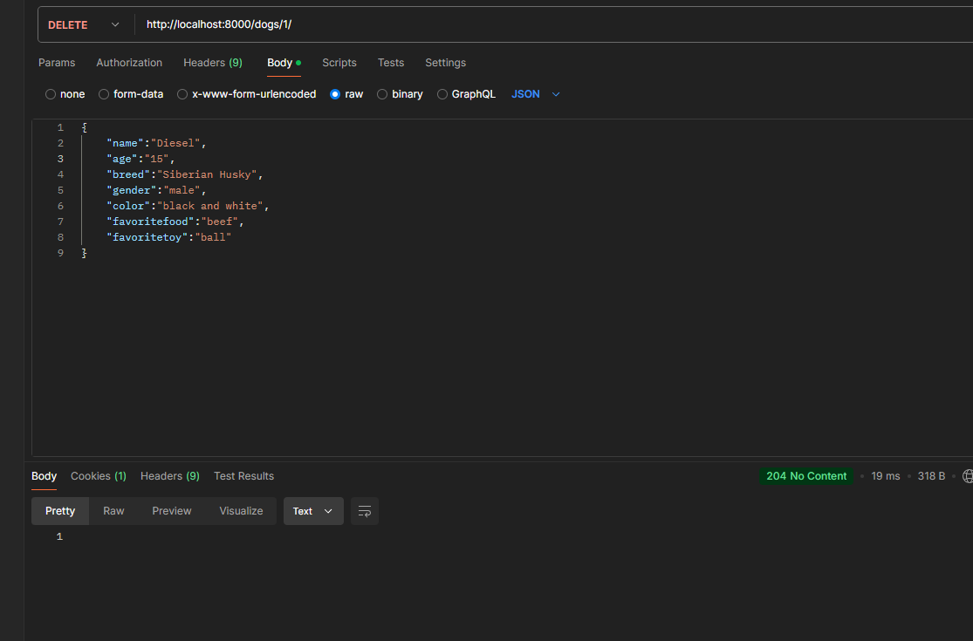

**Get all from breeds**

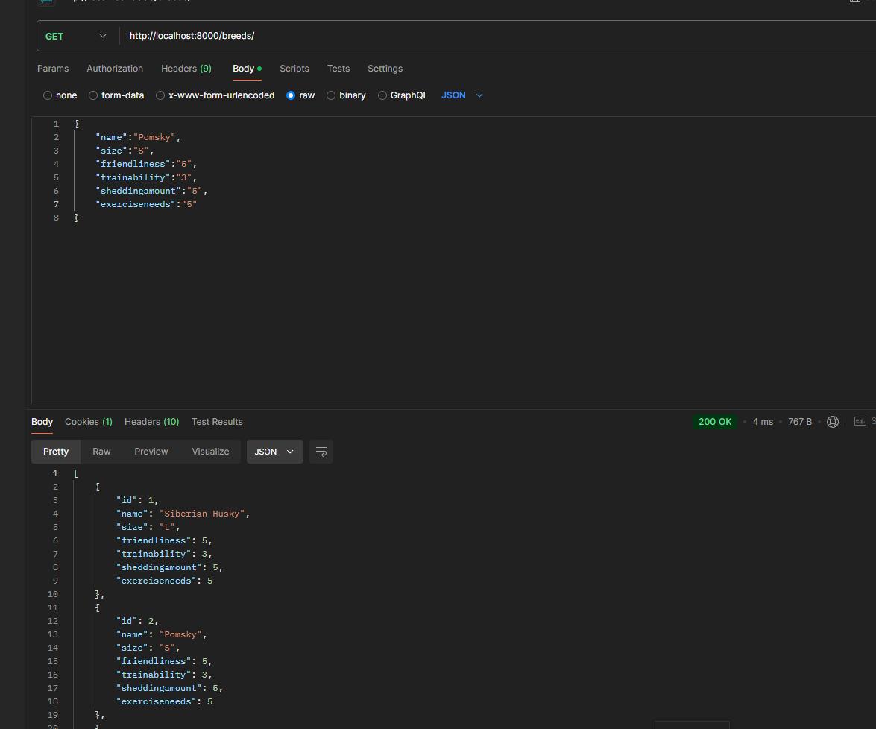

**Post to breeds**

**Get breed by id**

**Put to update breed by id**

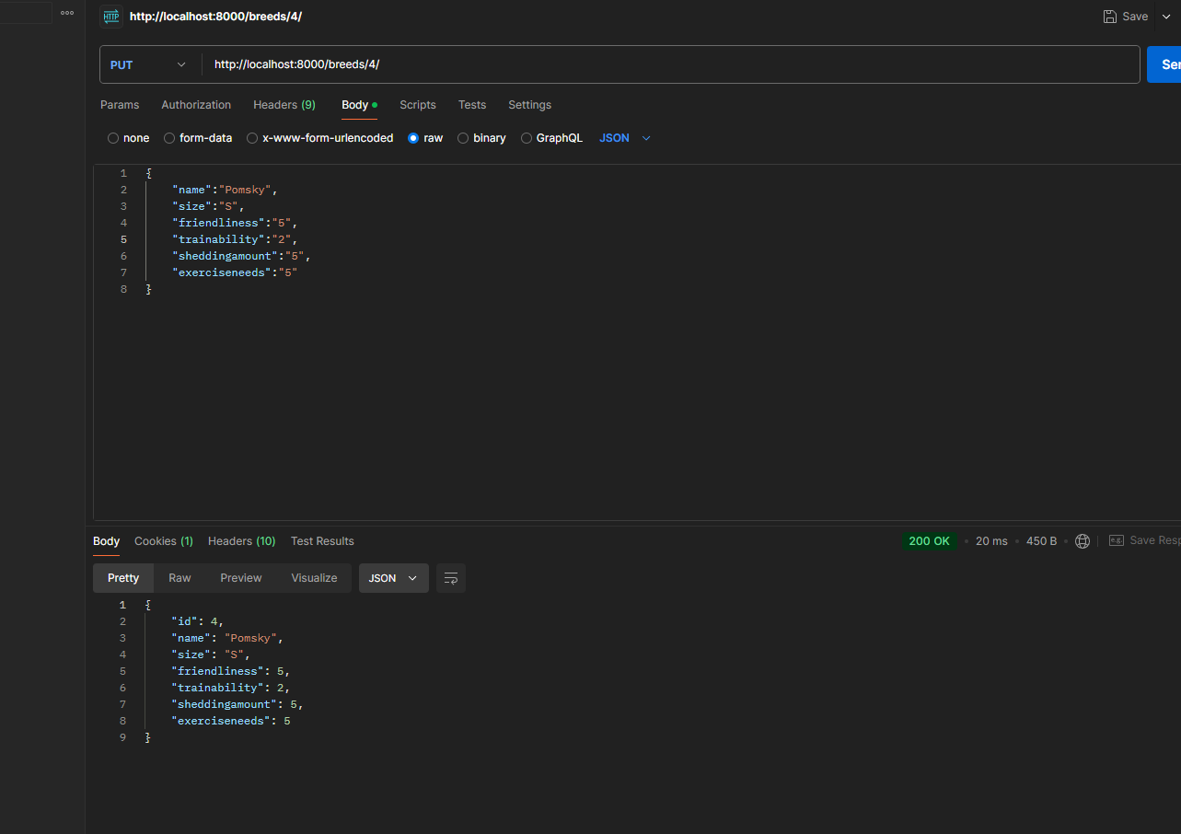

**Delete from breed by id**

